http://www.freepik.com/free-photos-vectors/fox

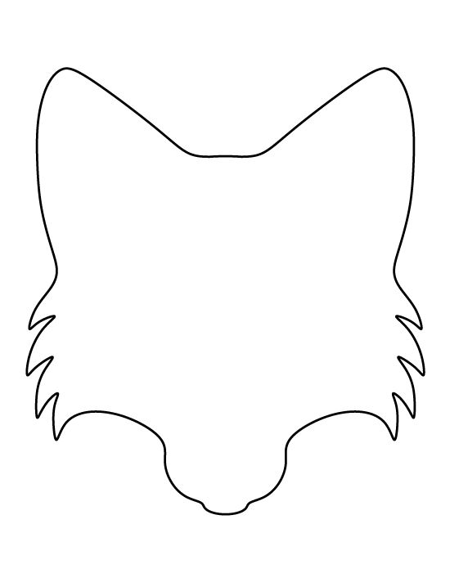 https://www.pinterest.com/pin/325455510548189667/

https://www.google.com/search?q=blank+head+graphic+organizer&safe=active&espv=2&biw=1440&bih=719&tbm=isch&imgil=-j-cXMvWjssifM%253A%253BGsMHI1SP6fWhmM%253Bhttps%25253A%25252F%25252Fwww.pinterest.com%25252Fpin%25252F100416266668959786%25252F&source=iu&pf=m&fir=-j-cXMvWjssifM%253A%252CGsMHI1SP6fWhmM%252C_&usg=__4-muEMLoyS0ai7iJUvTxwATWyv0%3D&ved=0ahUKEwi91raHgb_PAhXCbT4KHd1VDZ8QyjcIKg&ei=AIHyV73WLcLb-QHdq7X4CQ#imgdii=-j-cXMvWjssifM%3A%3B-j-cXMvWjssifM%3A%3BdRmUXNhD2L_guM%3A&imgrc=-j-cXMvWjssifM%3A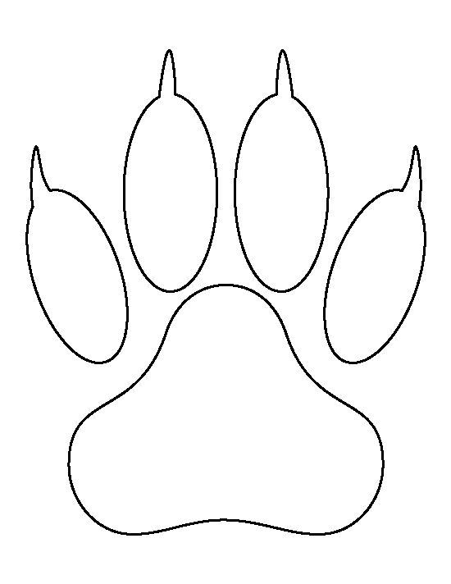
https://www.pinterest.com/akauni76/100/

