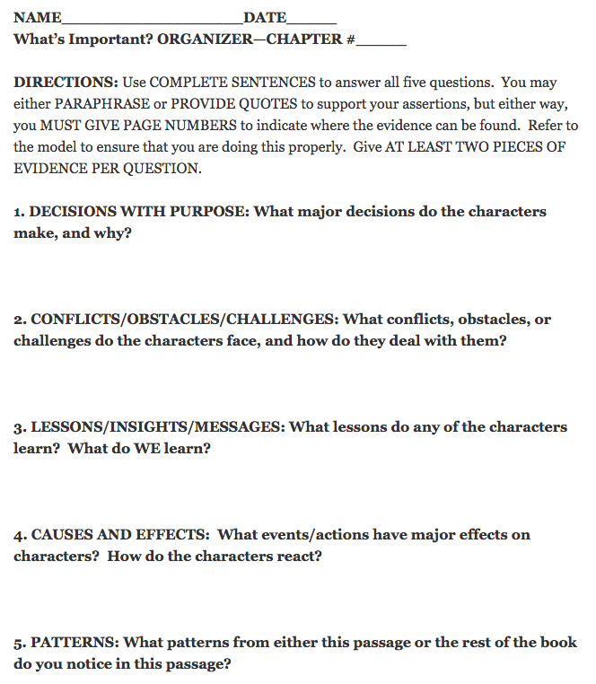

Sarah Tantillo previously blogged about this organizer HERE, and that original blog was adapted from The Literacy Cookbook.

