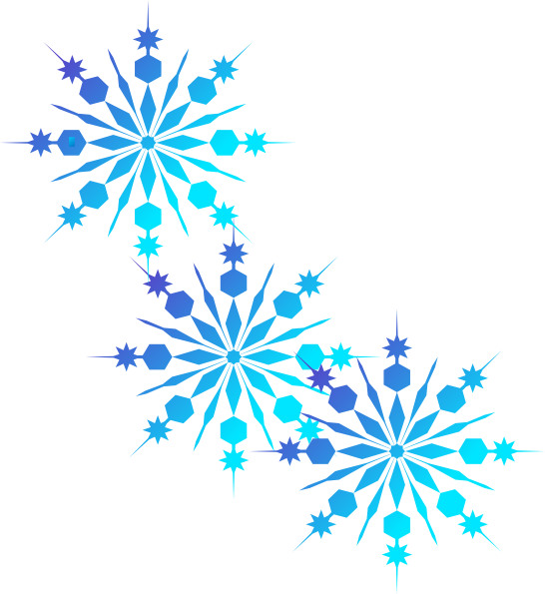Happy Holidays!

This document entitles you to one evening, entirely and unreservedly free of completing your homework commitment. Simply gather all related paperwork pertinent to the assignments designated on the evening of your choice. These can be identified as any printed worksheets or distributed materials that fall within the parameters of what was transcribed from the document that was projected on our SmartBoard via GoogleDrive in class that day, the document containing a list of single-night assignments.
Then, utilize a stapler to secure this official holiday document to the aforementioned documentation.
…and have a beautiful, safe, fun-filled vacation my dear! You’ve worked really hard since September…You deserve a break :)
Much love,
~Ms. Tarashuk

Happy Holidays!

This document entitles you to one evening, entirely and unreservedly free of completing your homework commitment. Simply gather all related paperwork pertinent to the assignments designated on the evening of your choice. These can be identified as any printed worksheets or distributed materials that fall within the parameters of what was transcribed from the document that was projected on our SmartBoard via GoogleDrive in class that day, the document containing a list of single-night assignments.
Then, utilize a stapler to secure this official holiday document to the aforementioned documentation.
…and have a beautiful, safe, fun-filled vacation my dear! You’ve worked really hard since September…You deserve a break :)
Much love,
~Ms. Tarashuk

