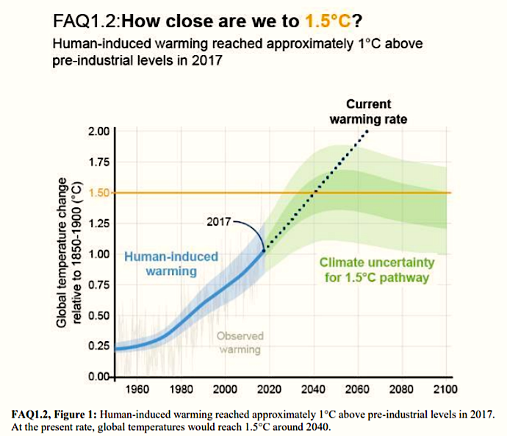
Source: The Insurance Journal (10/11/18)

Talking about Climate Change – An Urgent Classroom Discussion
There is a very real need to educate students about climate change.
Early in October 2018, the Intergovernmental Panel on Climate Change (IPCC) released a report highlighting a number of climate change impacts that could be ameliorated by limiting the increase in global warming (since pre-industrial times) to 1.5ºC compared to 2ºC or more.
Scientists and policy makers previously agreed that 2ºC should be the limit to prevent catastrophe. However, several small island countries disagreed with this limit because their communities would be inundated and destroyed by 2ºC of warming. The IPCC report confirms these island countries' concerns and demonstrates that limiting temperature rise to 1.5ºC above pre-industrial times would have fewer impacts.
Here is an excerpt from the findings:
“For instance, by 2100, global sea level rise would be 10 cm lower with global warming of 1.5°C compared with 2°C. The likelihood of an Arctic Ocean free of sea ice in summer would be once per century with global warming of 1.5°C, compared with at least once per decade with 2°C. Coral reefs would decline by 70-90 percent with global warming of 1.5°C, whereas virtually all (> 99 percent) would be lost with 2ºC.”
► Read more about the report at the United Nations website:
Special Climate Report: 1.5ºC Is Possible But Requires Unprecedented and Urgent Action
https://www.un.org/sustainabledevelopment/blog/2018/10/special-climate-report-1-5oc-is-possible-but-requires-unprecedented-and-urgent-action/
► Another article about the report appeared in The New Yorker, which noted that "Hurricane Maria devastated Puerto Rico in 2017. A new I.P.C.C. report predicts more extreme weather in the coming years if global temperatures continue to rise at the current rate."
The Dire Warnings of the United Nations’ Latest Climate-Change Report (10/8/18)
https://www.newyorker.com/news/news-desk/the-dire-warnings-of-the-united-nations-latest-climate-change-report

_________________________________________
Source: MiddleWeb, January 13, 2019
https://www.middleweb.com/39483/

